## SP2#17 5-March-2011 TO 24-March 2012

* 4 channel instr
* Calibrations done?
* 'acq_rate': 5000000,
* Sample rate was 1/1 always, but data was written 1 of every 10 minutes from 20110301 on
* hk_dict = {
  + 'yag_min':4,
  + 'yag_max':7,
  + 'sample_flow_min':118.5,
  + 'sample_flow_max':121.5,
  + 'sheath_flow_min':990,
  + 'sheath_flow_max':1010,
  + }
* zeroX_evap_threshold = 40
* min_incand = 10
* fit_factor = 15
* FF_bump = (for ratio method) determined empirically

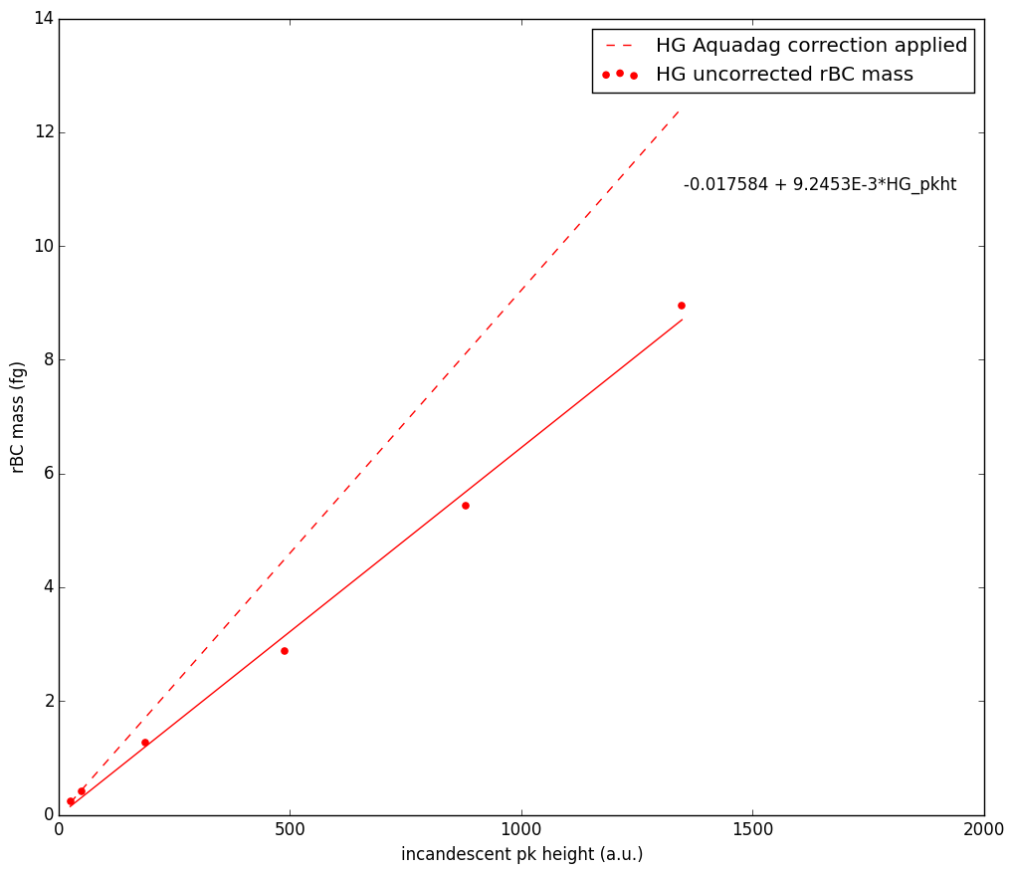

## SP2#44 27-March-2012 TO 22-Sept-2013

* 8 channel instr
* Calibrations done:
  + March 7, 2012
* 'acq_rate': 2500000 record size 1658
* Sample rate 1/8 – always
* Hk file format does not include UTC ts
* Using HG BB channel
* hk_dict = {
  + 'yag_min':1.5,
  + 'yag_max':7,
  + 'sample_flow_min':118.5,
  + 'sample_flow_max':121.5,
  + 'sheath_flow_min':992,
  + 'sheath_flow_max':1006,
  + }
* zeroX_evap_threshold = 2000
* min_incand = 50
* fit_factor = 15
* FF_bump = 3 (for ratio method) determined empirically

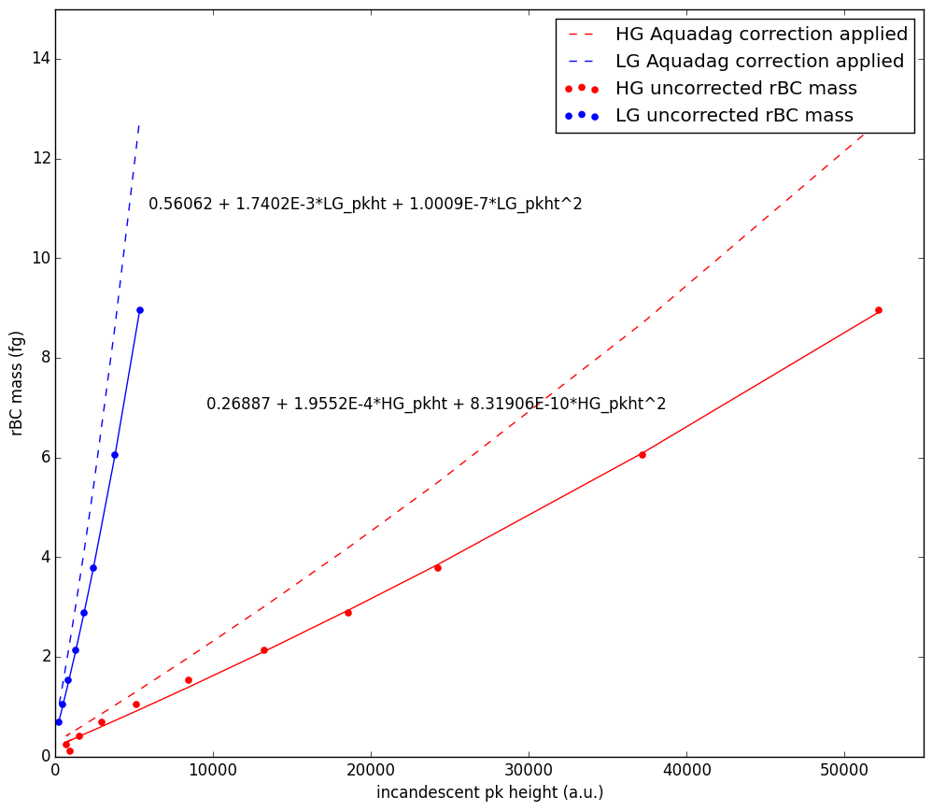

## SP2#58  27-Sept-2013 TO Current

* 8 channel instr
* Calibrations done:
  + Nov 6, 2012 – AD, PSL
  + Aug 30, 2014 - AD
  + April 11, 2015 - AD
  + Dec 1, 2015 – AD, PSL
* 'acq_rate': 2500000 record size 1658
* Sample rate 1/10 - always
* Hk file format includes UTC ts
* Using HG BB channel
* hk_dict = {
  + 'yag_min':4,
  + 'yag_max':6,
  + 'sample_flow_min':118.5,
  + 'sample_flow_max':121.5,
  + 'sheath_flow_min':992,
  + 'sheath_flow_max':1006,
* zeroX_evap_threshold = 2000
* FF_bump = 4 (for ratio method) determined empirically

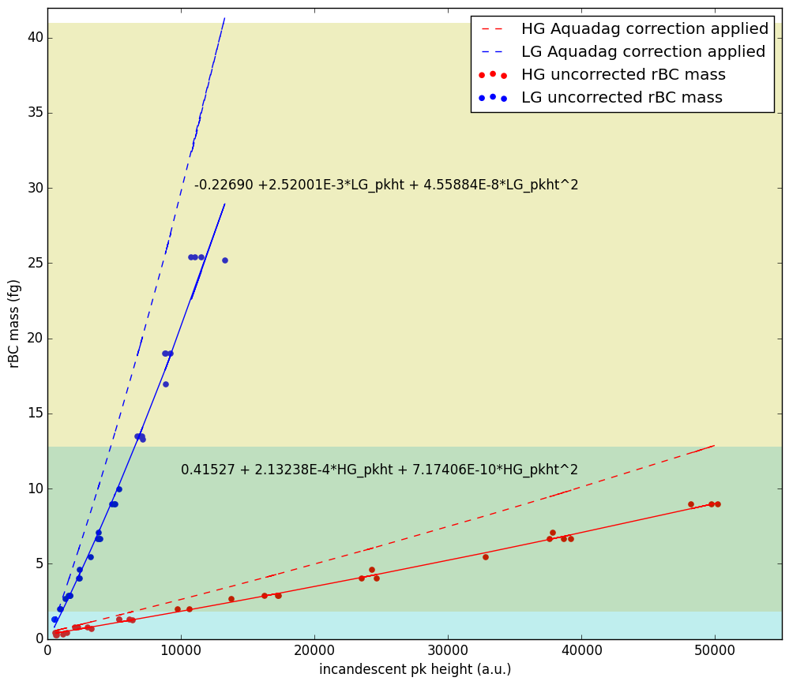

## LEO Procedure:

1. Averaged hk data over 1 min and added to db. will check these intervals and avoid any minutes where flows and yag out of range
   1. #44 ranges are:
      1. 118.5 < sample flow < 121.5
      2. 992 < sheath flow < 1006
      3. 2 < yag voltage < 6
      4. 22 < xtal temp < 48
   2. #58 ranges are:
      1. 118.5 < sample flow < 121.5
      2. 992 < sheath flow < 1006
      3. 4 < yag voltage < 6
      4. 29.5 < xtal temp < 30.5
2. For each day of analysis, wrote ~10,000 nonincand LEO parameters (gauss width and position) to “alert_leo_params_from_nonincands” and will use these to fix gauss width and position in fitting incandescent particles
3. Checked that LEO was reproducing the FF value well
   1. Note that the simple ratio method is as good or better than the LEO fitting!
4. Ran LEO fits

## Mass calculations:

2011 – 2013 analysis:

2011 is done 20110305 to 20120101 from C: (SP2 #17) to txt done

2012 is done 20120101 to 20120324 from F: (SP2 #17) to txt running - AL_1h_timeseries_HG_4ch.py

2012 is done 20120401 to 20130101 from F: (SP2 #44) to txt running - test_1h_write.py

2013 is done 20130101 to 20130922 from F: (2) (SP2 #44) to txt running - AL_1h_timeseries_HG.py

2013 is done 20120927 to 20131231 (SP2#58)

(1) Gysel, M.; Laborde, M.; Olfert, J. S.; Subramanian, R.; Gröhn, a. J. *Atmos. Meas. Tech.* **2011**, *4*, 2851–2858.

(2) Laborde, M.; Mertes, P.; Zieger, P.; Dommen, J.; Baltensperger, U.; Gysel, M. *Atmos. Meas. Tech.* **2012**, *5*, 1031–1043.